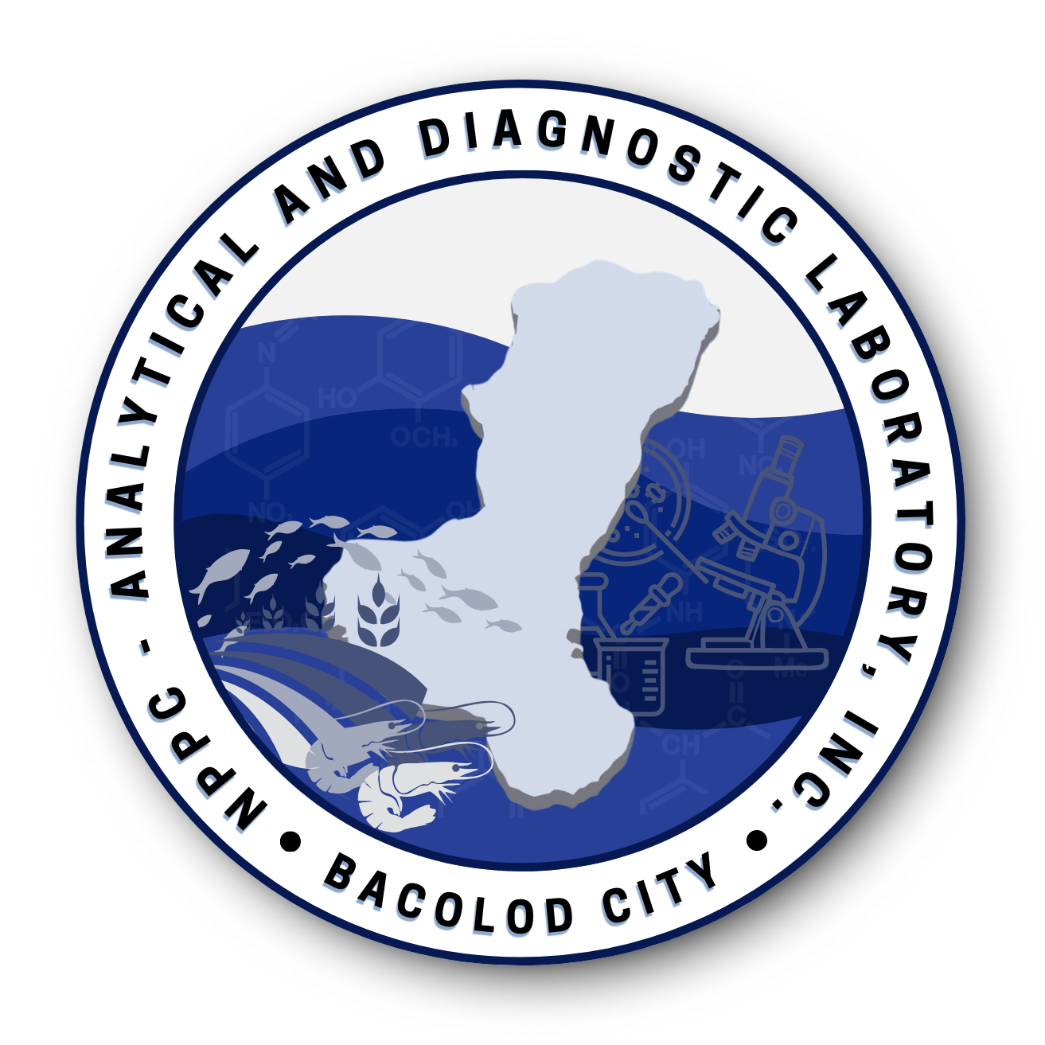
NPPC ANALYTICAL AND DIAGNOSTIC LABORATORY, INC.
Blk 2 Lot 29 San Vicente, Sta. Clara Subd., Circumferential Road, Brgy. Banago, Bacolod City
Tel. No. 034-4352613 email address nppclab@gmail.com

Customer :
Address :
Specimen :
Date Submitted :
Date Reported :
Reference No :

LABORATORY TEST RESULTS

TEST | Control Number  Sample Description:
% Total Solids  Gravimetric Method | 16.54
%Total Soluble Solids  Refractometer | 15.70
pH  Electrometric Method | 6.17
%Fat  Soxhlet Extraction Method | 3.35
%Solid Not Fat, SNF  (Computed Total Solid – Total Fat) | 13.19

NOTES : 1. Results of examination specifically related to samples as received.
2. Test results shall not be reproduced without the approval of the Laboratory Head.

Analyzed by: Approved by:

Ferresa Mae O. Caberoy, RCh Wendy A. Tayson, RCh, MEE
Laboratory Analyst Laboratory Head
PRC License No. 16125 PRC License No. 15131

NPPC ADL
LSP 7.8 F016
Rev 05 / Issue 06
Effectivity Date: 07/15/2026

